Step1 🡪Naming Test plan As Demonstrating Recording Test Plan

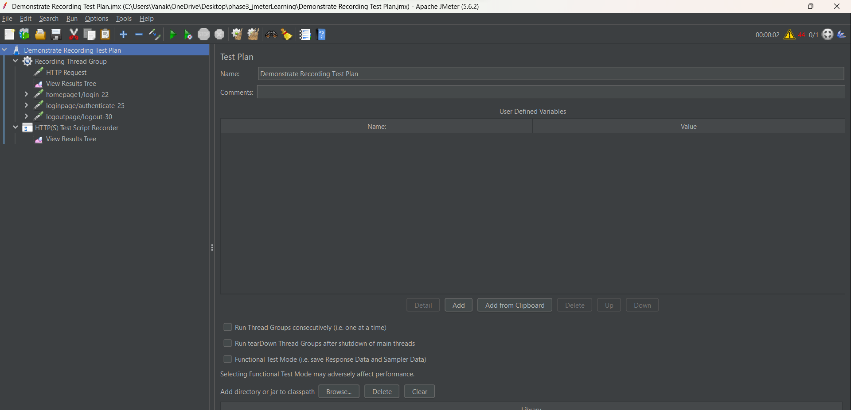

Step 2:-Adding ThreadGroup By right clicking TestPlan and then click on Add

Then click on threads(users)And click on Thread group.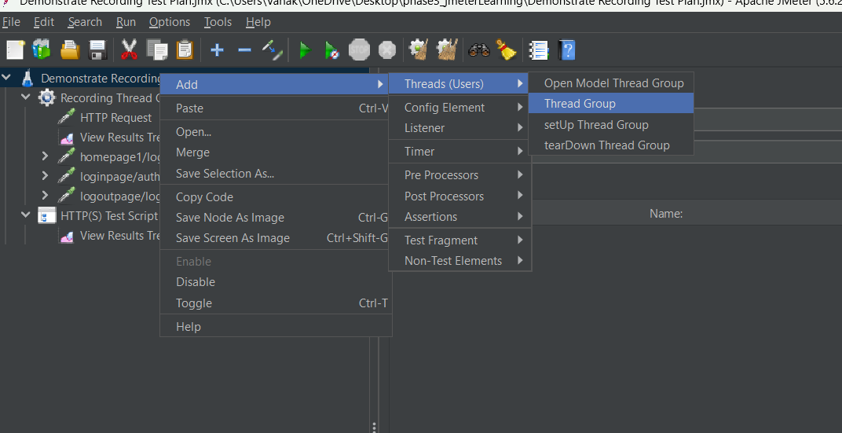

Step3:-Right click on the Thread group and click on the add, then click on the sampler ,then click on the http request.

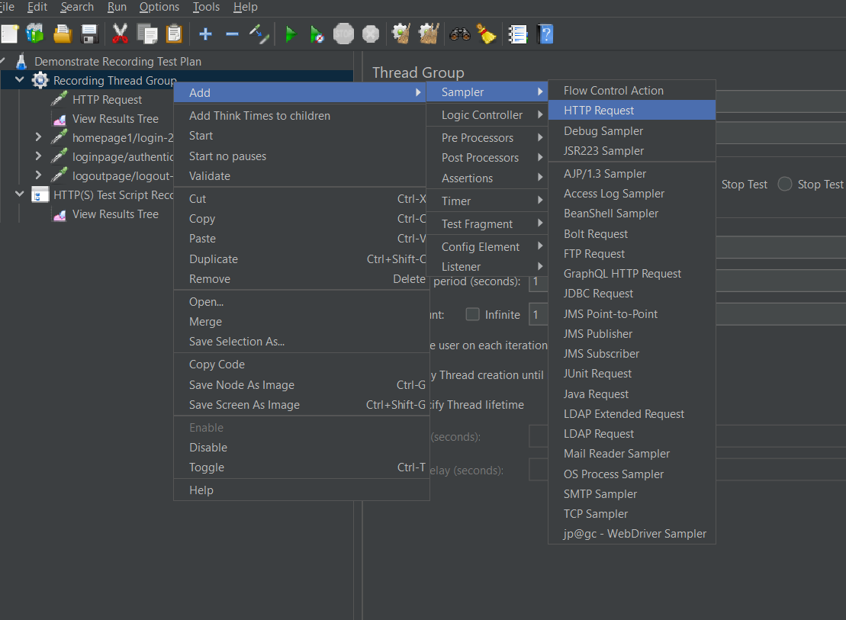

Step4:- Click on the http request

In Web Server

Add

Protocol(https):-https

ServerName or Ip:- the-internet.herokuapp.com

Path:- /

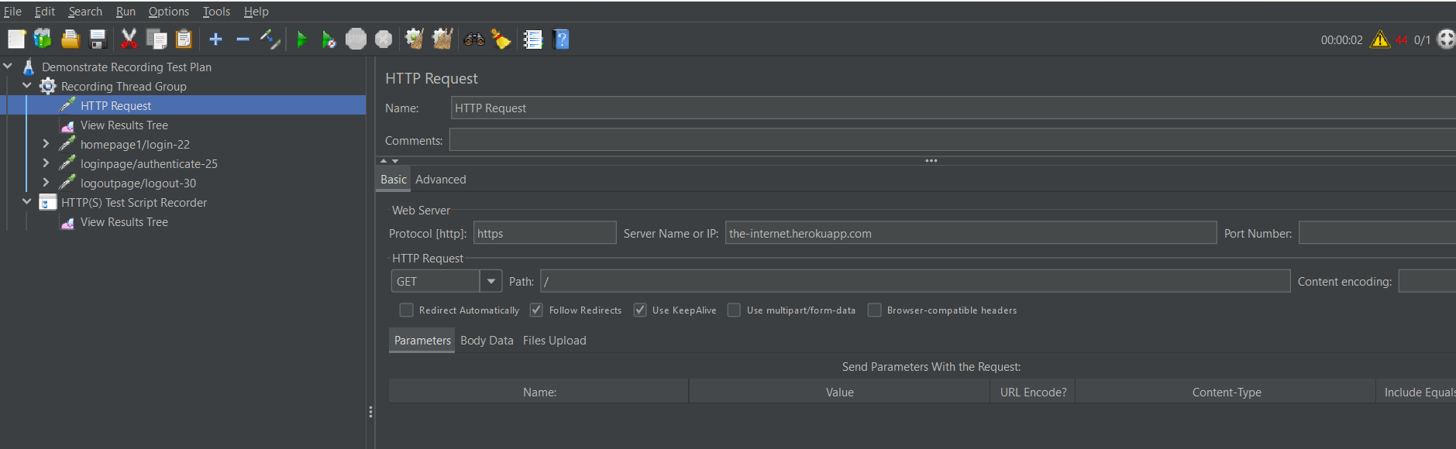

Step 4:- Right click on the Test plan, click on the add then click on the non -test element ,Then click on the HTTP(S) Test Script Recorder

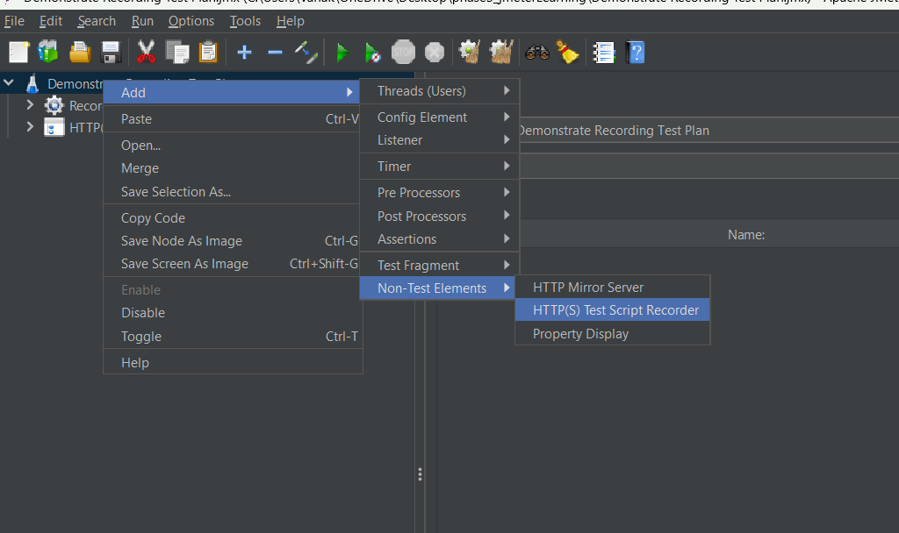

Step 5:-In HTTP(S) Test Script Recorder ,In Target controller:- select the option where we have to record.

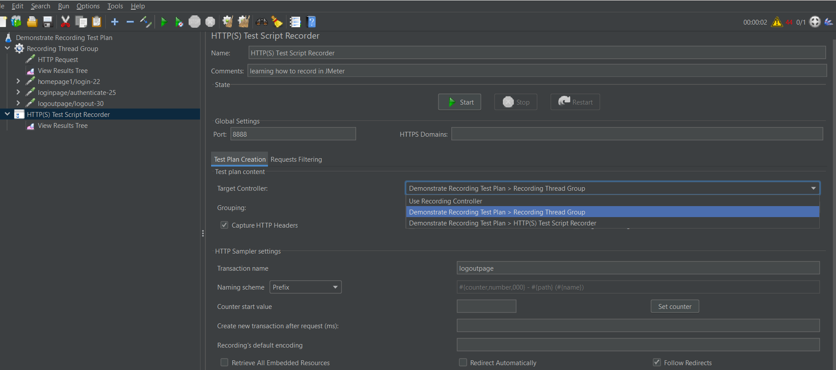

Step:-5 Add listner by right click on the Thread Group/HTTP(S) Test Script Recorder.click on Add,Then click on listner ,then click on View Result Tree.

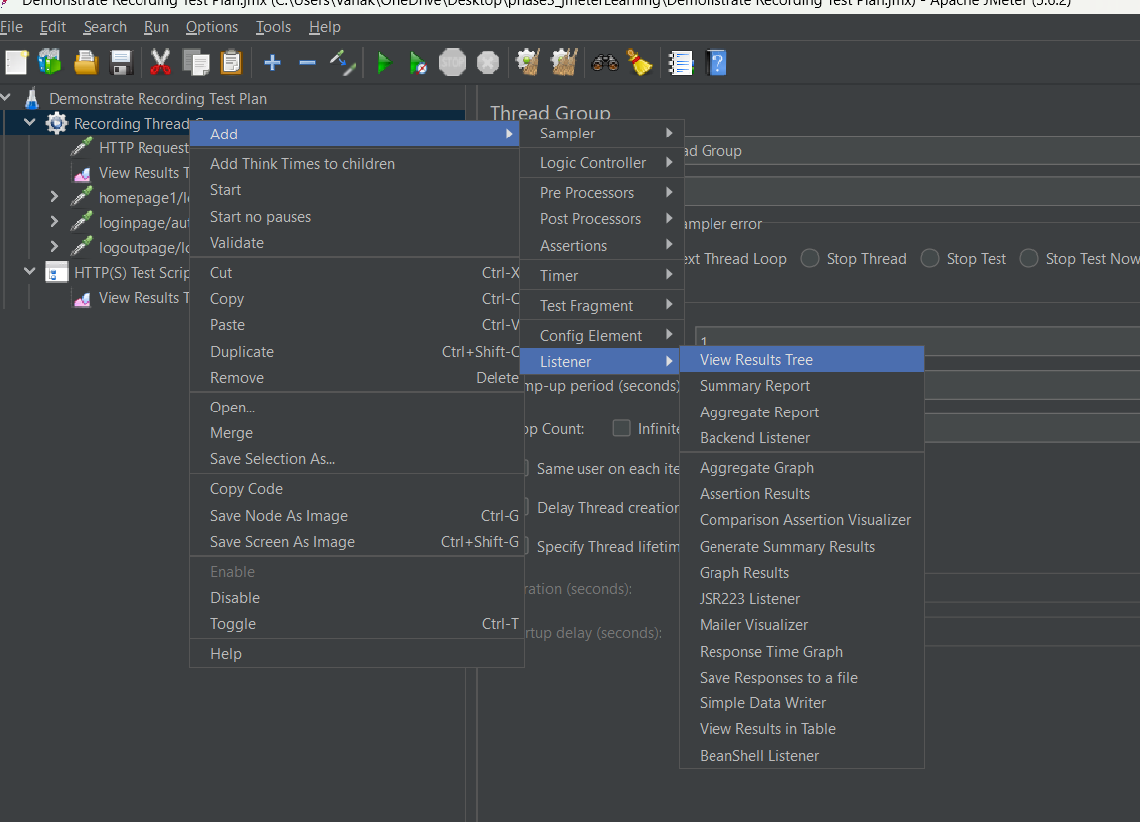

Then click on start record.

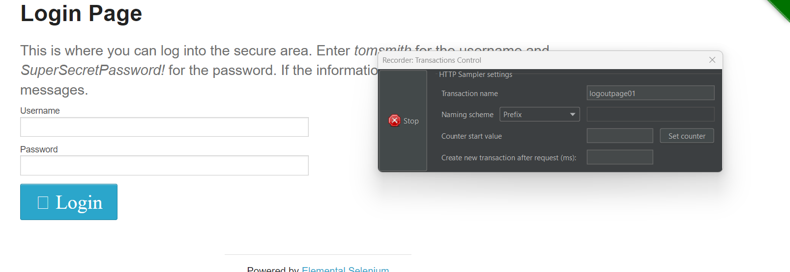

Then run the recording Theard Group .

